CONFIDENTIAL CS/OCT 2026/MAT133

UNIVERSITI TEKNOLOGI MARA FINAL EXAMINATION

COURSE
COURSE CODE
EXAMINATION TIME
PRE CALCULUS
MAT133 OCTOBER 2026
2 HOURS

INSTRUCTIONS TO CANDIDATES

- This question paper consists of 5 questions.

- Answer ALL questions in the Answer Booklet. Start each answer on a new page.

- Do not bring any material into the examination room unless permission is given by the invigilator .
- Please check to make sure that this examination pack consists of: i) the Question Paper
  - a one - page Append ix 1
  - an Answer Booklet - provided by the Faculty
  - a graph paper - provided by the Faculty

- Answer ALL questions in English.

/

DO NOT TURN THIS PAGE UNTIL YOU ARE TOLD TO DO SO

This examination paper consists of 7 printed pages

QUESTION 1
a) Solve the inequality 5 - 3x <= -3. Express the answer in interval notation.
(4 marks)
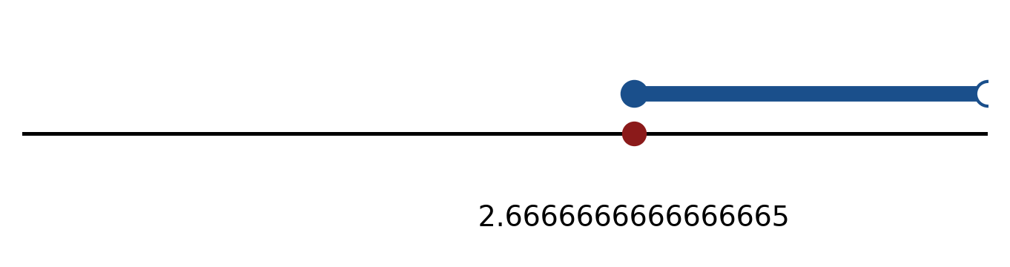
Figure: solution on a number line.
b) Solve the inequality |3x + 3| > 4. Express the answer in interval notation and on a number line.
(5 marks)
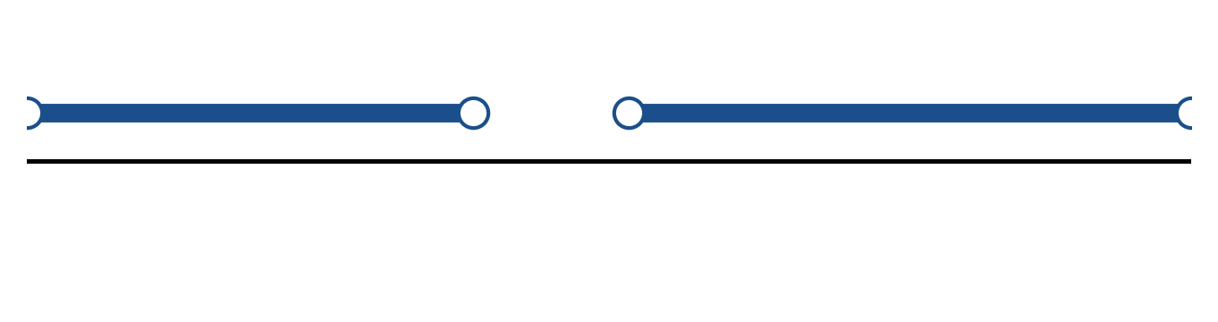
Figure: solution on a number line.
c) Solve the equation |5x + 3| = 8.
(4 marks)
QUESTION 2
a) Apply graph-transformation techniques to sketch y = -3(x - 4)² + 5. State the vertex and the y-intercept.
(5 marks)
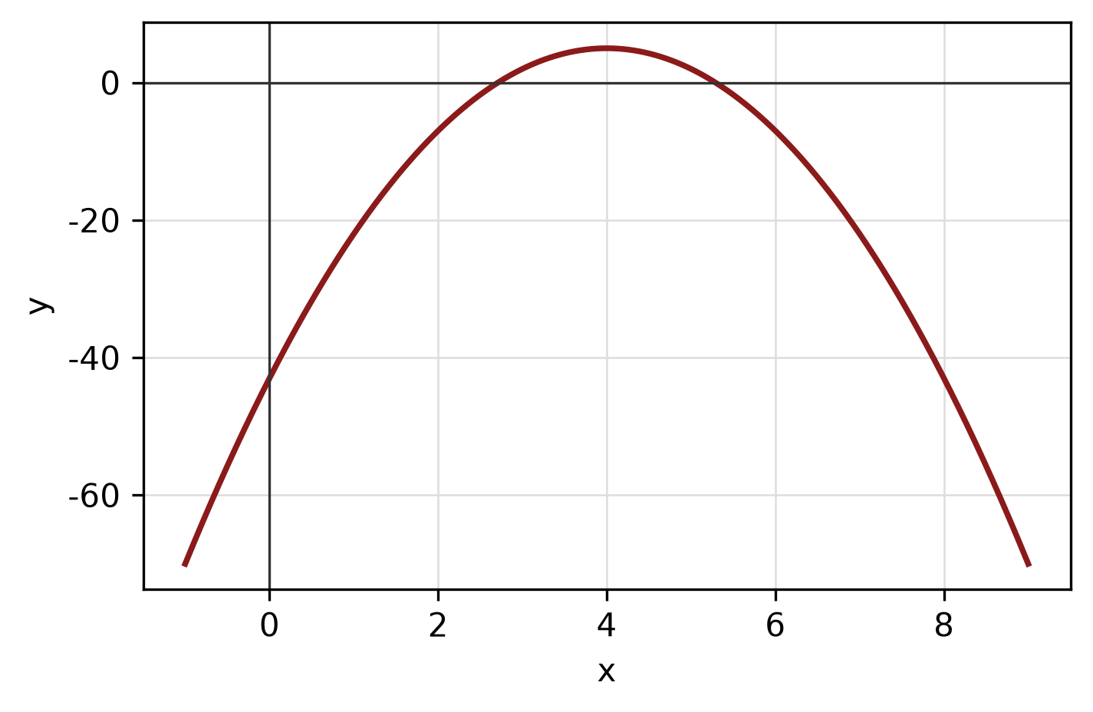
Figure: transformed graph.
b) The piecewise function is defined by
f(x) = -3x - 3, if x < -1;
f(x) = 5, if -1 ≤ x ≤ 2;
f(x) = x² - 3, if x > 2.
Sketch the graph and find f(-2), f(0) and f(3).
(5 marks)
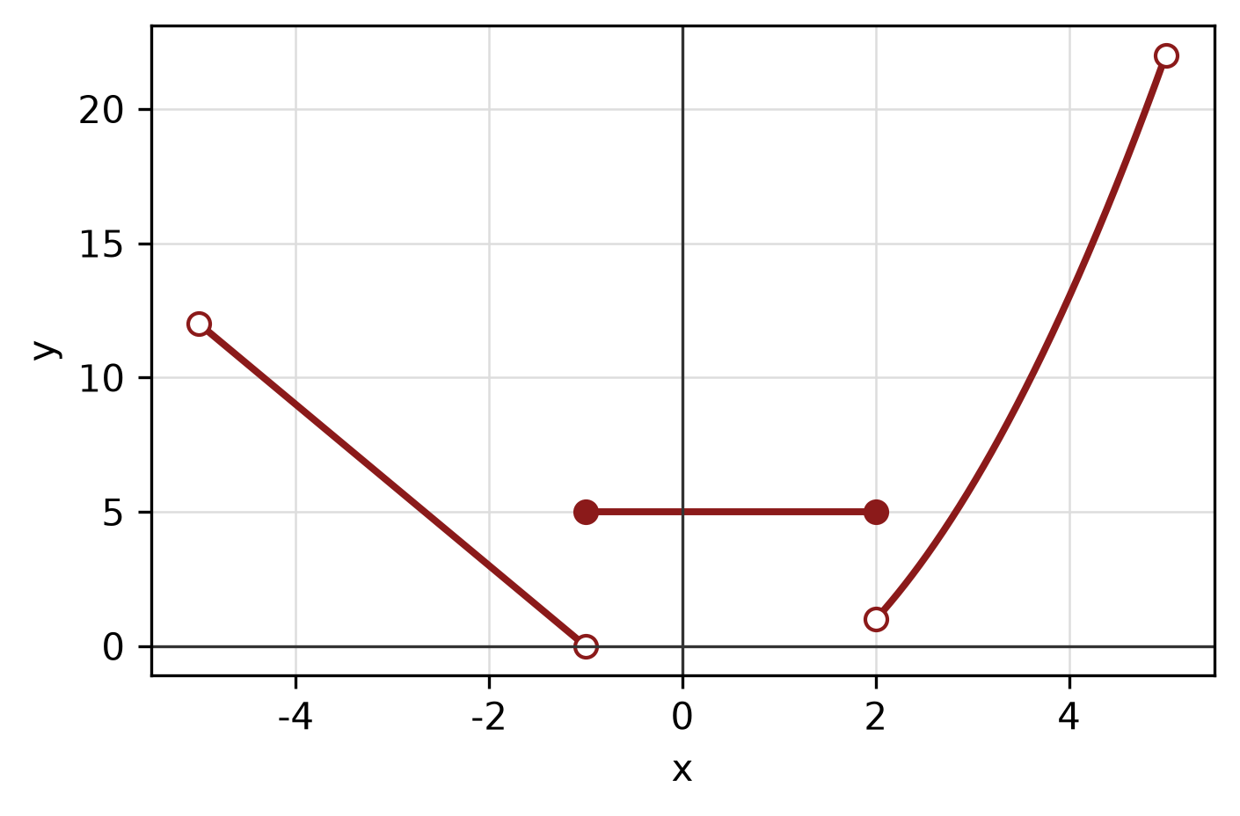
Figure: piecewise graph.
c) The endpoints of a diameter of a circle are (-1, -4) and (4, 5). Find the centre, radius and equation of the circle.
(5 marks)
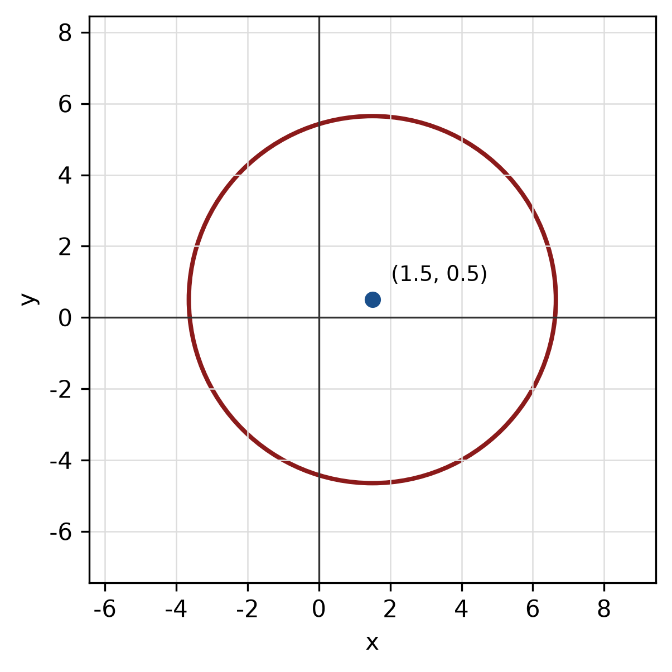
Figure: circle from diameter.
QUESTION 3
a) Given z₁ = 1 - 4i and z₂ = -2 - i, express z₁/z₂ in the form a + bi.
(5 marks)
b) Find the modulus and argument of z = -8 + 15i. Give the argument in degrees correct to one decimal place.
(5 marks)
c) Use long division to find the quotient and remainder when f(x) = -3x^3 + x² - 2x + 4 is divided by x + 4.
(5 marks)
QUESTION 4
a) Solve the system of equations simultaneously:
-2x - 2y - 3z = 0
-x + 2y + 4z = -12
3x - 2y + z = 20
(5 marks)
b) Solve the simultaneous equations
-5x + y = 8
4x - 5y = 2.
(4 marks)
c) Write the equation of the circle with centre (-4, -2) and radius 2. Hence write its general equation and sketch the circle.
(5 marks)
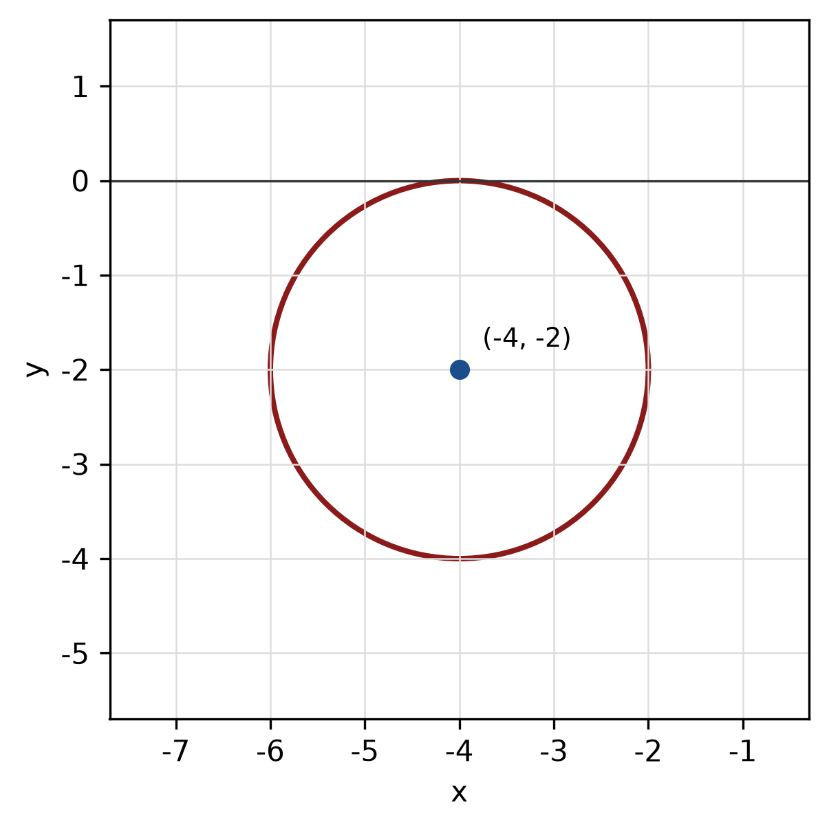
Figure: circle.
QUESTION 5
a) Solve the trigonometric equation -cos² x = 0 for 0° ≤ x < 360°.
(5 marks)
b) Find the area of the sector of a circle with radius 6 cm and central angle 150°.
(4 marks)
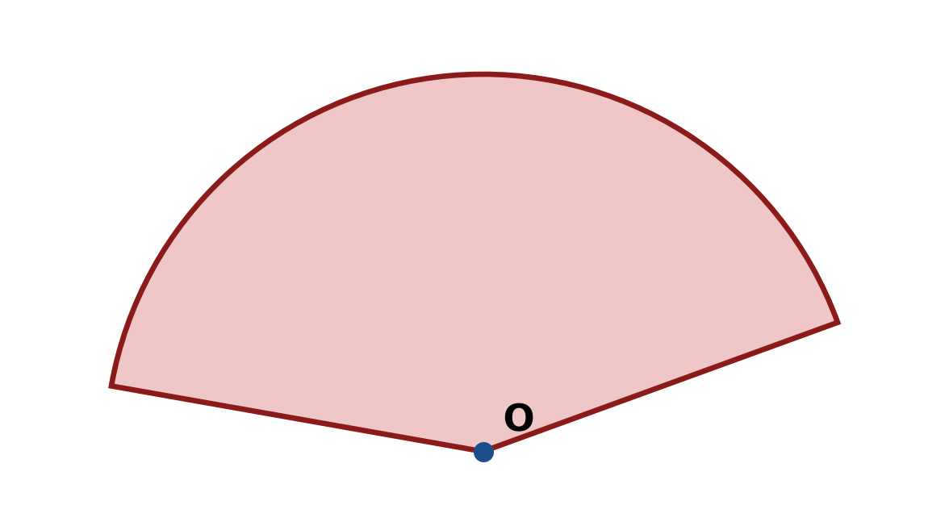
Figure: sector.
c) Solve the triangle with sides a = 5 cm, b = 12 cm and c = 13 cm. Find all three angles.
(5 marks)
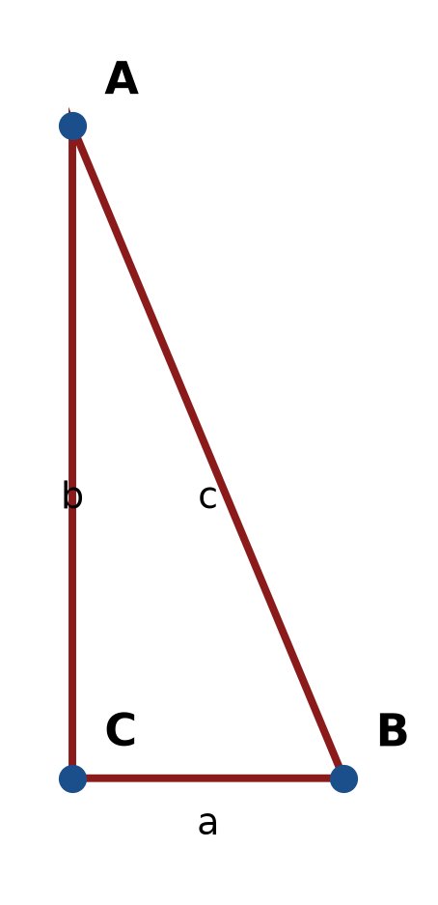
Figure: right triangle.
END OF QUESTION PAPER

APPENDIX 1
Formula sheet (as supplied with the paper).
sin² A + cos² A = 1 | tan² A + 1 = sec² A
sin(A + B) = sin A cos B + cos A sin B | tan 2A = 2 tan A / (1 − tan² A)
cos(A + B) = cos A cos B − sin A sin B | Arc length, s = rθ
tan(A − B) = (tan A − tan B) / (1 + tan A tan B) | Area of sector = ½r²θ
cos 2A = cos² A − sin² A | a / sin A = b / sin B = c / sin C
cos 2A = 1 − 2sin² A = 2cos² A − 1 | a² = b² + c² − 2bc cos A
sin 2A = 2 sin A cos A | Area of triangle = ½ab sin C

